Case Study
Smart Surveillance System for the District of Jesus Maria, Lima, Peru
Client: Municipality of Jesus Maria | Project Duration: 6 Months
Technologies Used: Computer Vision, AI/ML, Edge Computing, Real-Time Alert Systems, Cloud Integration, REST APIs, IoT Cameras, Geospatial Mapping, React Native, FastAPI

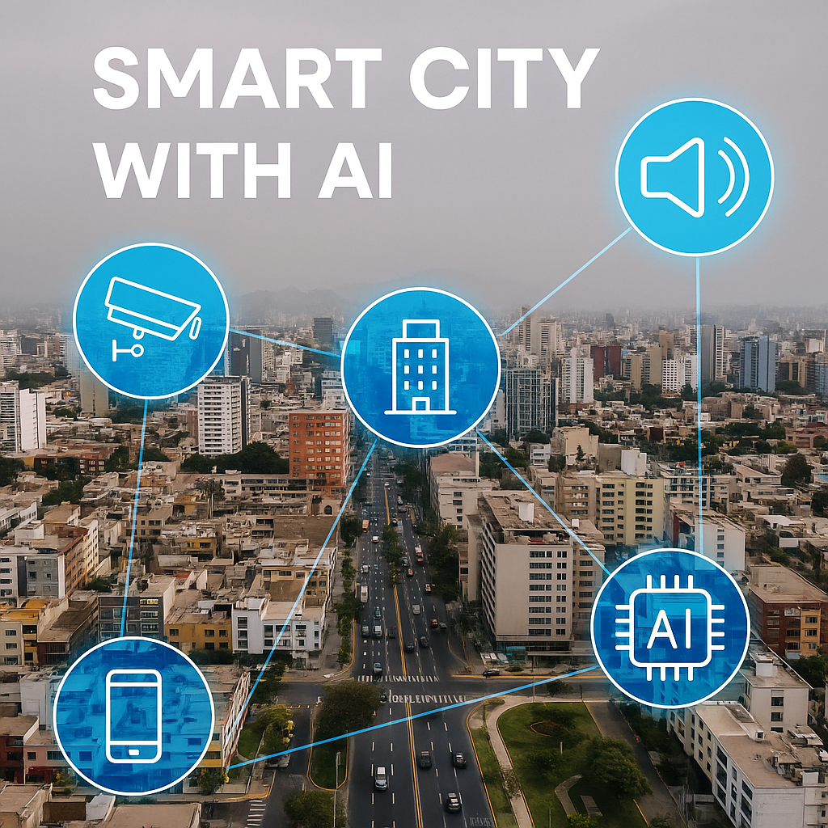
Robles.AI collaborated with the Municipality of Jesus Maria to implement an AI-powered Smart Surveillance System designed to reduce crime rates and improve emergency response times. Within six months of deployment, the district experienced a 27% reduction in crime and a 42% improvement in emergency response times. This initiative marked a significant milestone in transforming Jesus Maria into one of Lima's leading smart city districts.
Components & Architecture
- Smart Cameras: Over 200 edge-powered HD cameras with computer vision capabilities deployed at key intersections, parks, and commercial areas
- AI Engine: Real-time object detection, abnormal behavior recognition, and license plate tracking powered by YOLOv8 and OpenCV
- Edge + Cloud: Local edge processors handle preliminary analysis; relevant data is sent to cloud for archival and further analytics
- Community App: React Native app enabling citizens to report incidents, access alerts, and provide feedback
- Municipal Dashboard: Admin interface built with Next.js and Tailwind, visualizing incident heatmaps, trends, and alerts
- Interoperability: REST APIs connected the platform with existing alarm systems and emergency lines

Project Stages
- Research & Community Engagement
  - Conducted surveys with 2,000 residents
  - Gathered inputs from 12 neighborhood boards
  - Identified 37 key surveillance zones

- Prototyping & Validation
  - Deployed pilot in Plaza San Jose and Av. Arnaldo Marquez
  - System evaluated by local police over 4 weeks
  - Achieved 93% accuracy in detection of crowding, aggression, and trespassing
- Deployment & Integration
  - Scaled across entire district with real-time streaming
  - Integrated with sirens, panic buttons, and legacy systems
- Training & Onboarding
  - Trained 34 municipal officers and 72 community volunteers
  - Onboarded 5,000+ residents onto the mobile app

Case Study
Smart Surveillance System for the District of Jesus Maria, Lima, Peru
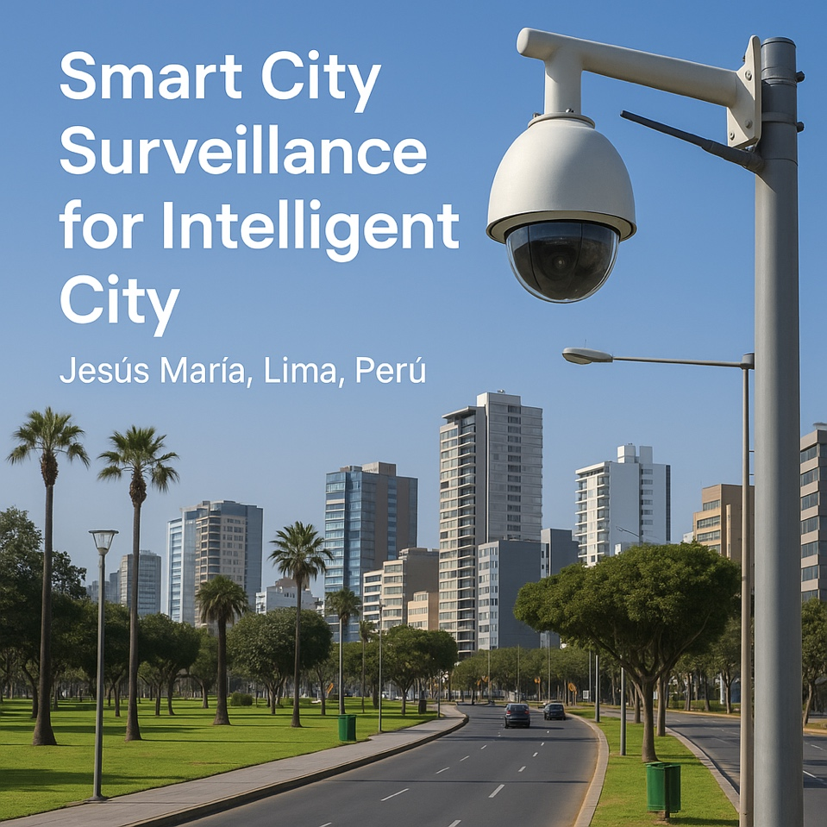
"Thanks to this system, for the first time, we feel like technology is working with us. The app gives us peace of mind, and the security guards arrive quickly when something happens."
—President of Neighborhood Board No. 3, Cuba Avenue

Results
- 27% crime reduction within six months (based on municipal crime reports)
- 42% faster emergency response thanks to real-time alerts and geolocation
- 89% community satisfaction based on follow-up surveys

Community Impact
Residents reported feeling safer in previously vulnerable zones. The mobile app enabled swift communication and transparency between authorities and civilians. Neighborhood watch groups played a pivotal role by providing feedback and flagging technical anomalies.

Conclusion
This case exemplifies how AI-driven solutions can be tailored to meet the needs of local governments. With proper integration, training, and community collaboration, smart surveillance becomes a vital tool for building safer, more connected urban environments.

